I’m going to use this data for my Project;

[http://archive.ics.uci.edu/ml/datasets/Adult](https://archive.ics.uci.edu/ml/datasets/Adult)

Listing of attributes:  
  
>50K, <=50K.  
  
age: continuous.  
workclass: Private, Self-emp-not-inc, Self-emp-inc, Federal-gov, Local-gov, State-gov, Without-pay, Never-worked.  
fnlwgt: continuous.  
education: Bachelors, Some-college, 11th, HS-grad, Prof-school, Assoc-acdm, Assoc-voc, 9th, 7th-8th, 12th, Masters, 1st-4th, 10th, Doctorate, 5th-6th, Preschool.  
education-num: continuous.  
marital-status: Married-civ-spouse, Divorced, Never-married, Separated, Widowed, Married-spouse-absent, Married-AF-spouse.  
occupation: Tech-support, Craft-repair, Other-service, Sales, Exec-managerial, Prof-specialty, Handlers-cleaners, Machine-op-inspct, Adm-clerical, Farming-fishing, Transport-moving, Priv-house-serv, Protective-serv, Armed-Forces.  
relationship: Wife, Own-child, Husband, Not-in-family, Other-relative, Unmarried.  
race: White, Asian-Pac-Islander, Amer-Indian-Eskimo, Other, Black.  
sex: Female, Male.  
capital-gain: continuous.  
capital-loss: continuous.  
hours-per-week: continuous.  
native-country: United-States, Cambodia, England, Puerto-Rico, Canada, Germany, Outlying-US(Guam-USVI-etc), India, Japan, Greece, South, China, Cuba, Iran, Honduras, Philippines, Italy, Poland, Jamaica, Vietnam, Mexico, Portugal, Ireland, France, Dominican-Republic, Laos, Ecuador, Taiwan, Haiti, Columbia, Hungary, Guatemala, Nicaragua, Scotland, Thailand, Yugoslavia, El-Salvador, Trinadad&Tobago, Peru, Hong, Holand-Netherlands.

You can see the summary.

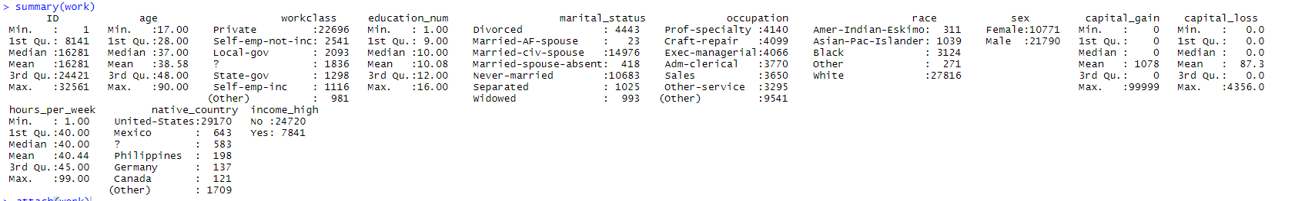

As you can see data has multiple attributes to examine. I want to focus on mostly race and education status later on if they have income-high. For that reason I’m planning to change race as White – non White and want to understand if income_high related to education or race more.